CC Car Settings

You can change the CC Car settings and CC Car pit stop strategies. To change this settings select a track and then select “CC Car Settings…” in the tools menu.

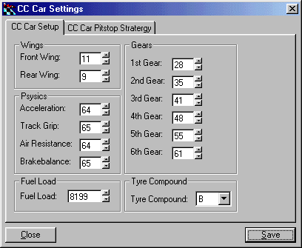
(CC Car Setup)

CC Car Setup
Here you can change the CC car setup and also some other values that affect the track and the cars on the track.

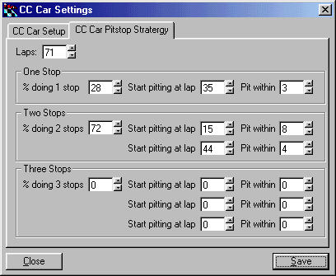
(CC Car Pit stop Strategy)

CC Car Pit stop Strategy
Here you can change when the computer cars will make their pit stops and how many pit stops they will make in a race.

